**Infrastructure**

Below are the name and link to the application/ tools used to build the infrastructure necessary for the completion of task on time and efficient communication among the team members:

* *Trello Board*: The name of team Trello board is “*csri-tribe-squad1"*. The link to the Trello board is< <https://trello.com/b/5hifsyfp/csri-tribe-squad1> >

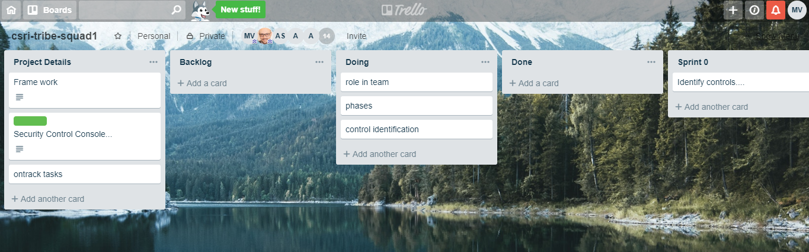Fig: 1

* *Slack:* The name of the team slack channel is “*csri_2019squad1”*. The link to the team slack channel is < <https://deakin-industry-2019.slack.com/messages/CH4AMH7D1> >

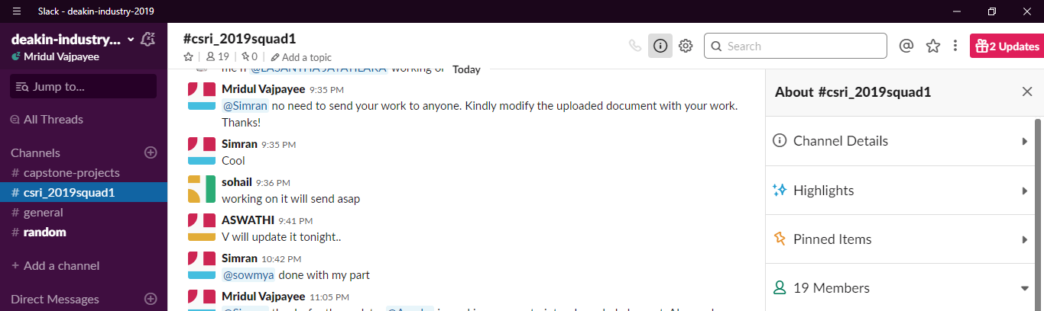Fig: 2

* *Mailing group:* The name of the group is *“_Student-Mailing-List CSRI-Tribe-Squad".* It is used for live document sharing using one drive. This full email address to the mailing group is <[_student-mailing-listcsri-tribe-squad2@deakin365.onmicrosoft.com](mailto:%3C_student-mailing-listcsri-tribe-squad2@deakin365.onmicrosoft.com) >.

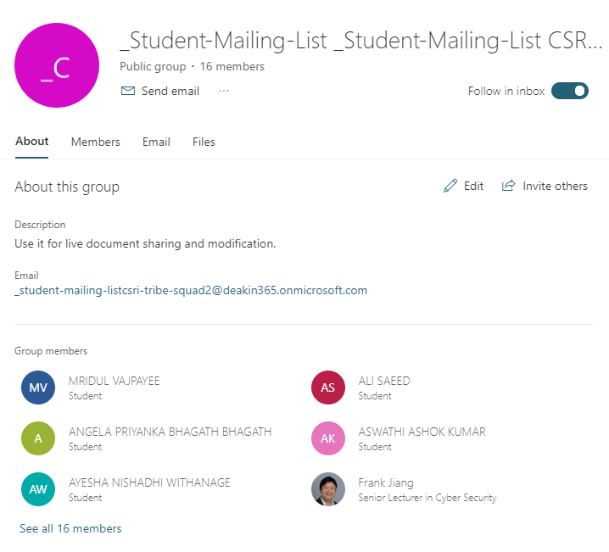Fig: 3